ASSIGNMENT 7

AIM 1:- Write a program to find entropy of an image. (Without using function)

Code:-

I=imread('lena.jpg');

if ~islogical(I)

I = im2uint8(I);

end

% calculate histogram counts

p = imhist(I(:));

% remove zero entries in p

p(p==0) = [];

% normalize p so that sum(p) is one.

p = p ./ numel(I);

E = -sum(p.*log2(p));

Output:-

>> entropy

Entropy:

E =

7.5976

AIM 2:- Write a program for image compression using huffman coding. Display compression ratio, Relative data redundancy and error. Display total no. of bits for original image and compressed image.

Code:-

Huff_code.m

%clearing all variableas and screen

clear all;

close all;

clc;

%Reading image

a=imread('lena.jpg');

a= imresize(a,[256 256]);

figure,imshow(a)

imwrite(a,'original.jpg');

%converting an image to grayscale

%I=rgb2gray(a);

I=a;

%size of the image

[m,n]=size(I);

Totalcount=m*n;

%variables using to find the probability

cnt=1;

sigma=0;

%computing the cumulative probability.

for i=0:255

k=I==i;

count(cnt)=sum(k(:))

%pro array is having the probabilities

pro(cnt)=count(cnt)/Totalcount;

sigma=sigma+pro(cnt);

cumpro(cnt)=sigma;

cnt=cnt+1;

end;

%Symbols for an image

symbols = [0:255];

%Huffman code Dictionary

dict = huffmandict(symbols,pro);

%function which converts array to vector

vec_size = 1;

for p = 1:m

for q = 1:n

newvec(vec_size) = I(p,q);

vec_size = vec_size+1;

end

end

%Huffman Encodig

hcode = huffmanenco(newvec,dict);

%Huffman Decoding

dhsig1 = huffmandeco(hcode,dict);

%convertign dhsig1 double to dhsig uint8

dhsig = uint8(dhsig1);

%vector to array conversion

dec_row=sqrt(length(dhsig));

dec_col=dec_row;

%variables using to convert vector 2 array

arr_row = 1;

arr_col = 1;

vec_si = 1;

for x = 1:m

for y = 1:n

back(x,y)=dhsig(vec_si);

arr_col = arr_col+1;

vec_si = vec_si + 1;

end

arr_row = arr_row+1;

end

imwrite(back,'decoded.jpg');

% %converting image from grayscale to rgb

% [deco, map] = gray2ind(back,256);

% RGB = ind2rgb(deco,map);

% imwrite(RGB,'decoded.JPG');

%end of the huffman coding

Hufftree.m

% hufftree.m

%

% given alphabet and probabilities: create huffman-tree

function [tree, table] = hufftree(alphabet,prob)

for l=1:length(alphabet) % create a vector of nodes (leaves), one for each letter

leaves(l).val = alphabet{l};

leaves(l).zero= '';

leaves(l).one='';

leaves(l).prob = prob(l);

end

% combine the two nodes with lowest probability to a new node with the summed prob.

% repeat until only one node is left

while length(leaves)>1

[dummy,I]=sort(prob);

prob = [prob(I(1))+prob(I(2)) prob(I(3:end))];

node.zero = leaves(I(1));

node.one = leaves(I(2));

node.prob = prob(1);

node.val = '';

leaves = [node leaves(I(3:end))];

end

% pass through the tree,

% remove unnecessary information

% and create table recursively (depth first)

table.val={}; table.code={};

[tree, table] = descend(leaves(1),table,'');

%%%%%%%%%%%%%%%%%%%%%%%%%%%%%%%%%%%%%%%%%%%%%%%%%%%%%%%%%%%%%%%%%%%%%%%%%%%%%%%%%%%

function [tree, table] = descend(oldtree, oldtable, code)

table = oldtable;

if(~isempty(oldtree.val))

tree.val = oldtree.val;

table.val{end+1} = oldtree.val;

table.code{end+1} = code;

else

[tree0, table] = descend(oldtree.zero, table, strcat(code,'0'));

[tree1, table] = descend(oldtree.one, table, strcat(code,'1'));

tree.zero=tree0;

tree.one= tree1;

end

huffencode.m

% huffencode.m

%

% takes a cell-vector and a huffman-table

% returns a huffman encoded bit-string

function bitstring = huffencode(input, table)

bitstring = '';

for l=1:length(input),

bitstring = strcat(bitstring,table.code{strcmp(table.val,input{l})}); % omits letters that are not in alphabet

end;

huffdecode.m

% huffdecode.m

%

% takes a bit-string and a huffman-tree

% returns a decoded cell array

function message = huffdecode(bitstring, tree)

treepos = tree;

counter = 1;

for l=1:length(bitstring)

if(bitstring(l) == '1')

treepos = treepos.one;

else

treepos = treepos.zero;

end

if(isfield(treepos,'val'))

message{counter} = treepos.val;

counter = counter+1;

treepos = tree;

end

end

Output:-

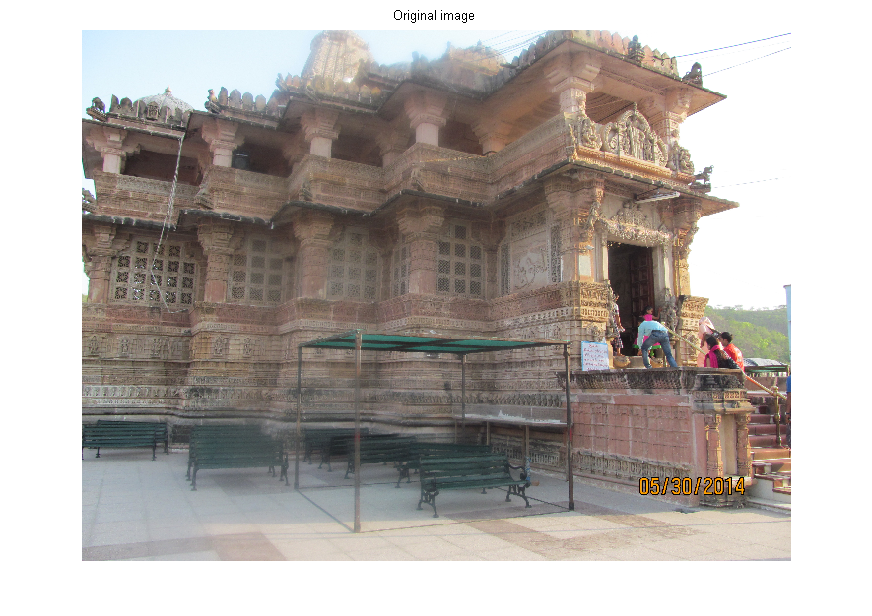

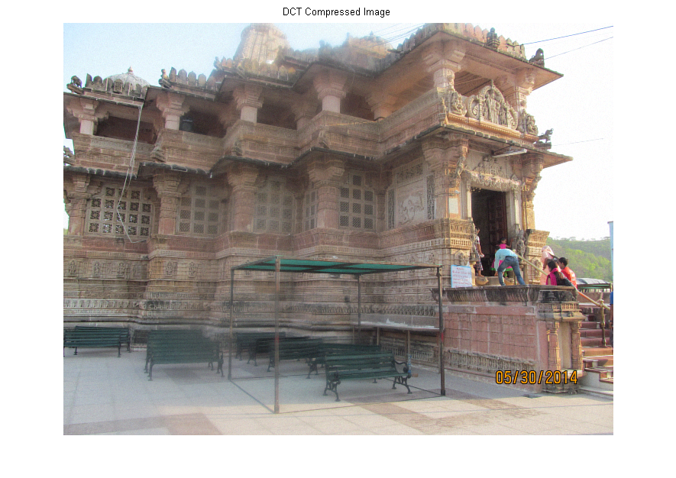

AIM 3:-Write a program for image compression using DCT. Display compression ratio, Relative data redundancy and error. Display compression ratio, Relative data redundancy and error.

Code:-

clc

clear all

close all

I = imread('cameraman.tif');

I = im2double(I);

T = dctmtx(8);

B = blkproc(I,[8 8],'P1*x*P2',T,T');

mask = [1 1 1 1 0 0 0 0

1 1 1 0 0 0 0 0

1 1 0 0 0 0 0 0

1 0 0 0 0 0 0 0

0 0 0 0 0 0 0 0

0 0 0 0 0 0 0 0

0 0 0 0 0 0 0 0

0 0 0 0 0 0 0 0];

B2 = blkproc(B,[8 8],'P1.*x',mask);

I2 = blkproc(B2,[8 8],'P1*x*P2',T',T);

imshow(I), figure, imshow(I2)

imwrite(I2,'cmp.tif')

fileName = 'cameraman.tif';

rm1=rms(fileName);

fileInfo = imfinfo(fileName);

sz1 = fileInfo.FileSize;

fileName = 'cmp.tif';

rm2=rms(fileName);

fileInfo = imfinfo(fileName);

sz2 = fileInfo.FileSize;

display('Compression Ratio is:');

display(sz2/sz1);

display('ERROR IS');

er=(rm1*rm1)-(rm2*rm2);

er=sqrt(er);

display(er);

display('Relative Data Redundency');

I=imread('cameraman.tif');

if ~islogical(I)

I = im2uint8(I);

end

% calculate histogram counts

p = imhist(I(:));

% remove zero entries in p

p(p==0) = [];

% normalize p so that sum(p) is one.

p = p ./ numel(I);

E1 = -sum(p.*log2(p));

I=imread('cmp.tif');

if ~islogical(I)

I = im2uint8(I);

end

% calculate histogram counts

p = imhist(I(:));

% remove zero entries in p

p(p==0) = [];

% normalize p so that sum(p) is one.

p = p ./ numel(I);

E2 = -sum(p.*log2(p));

display('Relative Data Redundancy');

ex=E2-E1;

display(ex);

Output:-

Compression Ratio is:

ans =

0.9068

ERROR IS

er =

11.7973

Relative Data Redundency

Relative Data Redundancy

ex =

0.0971

Original Image:-

D:\MAT-DIP-LAB-TVR\Assignment6\cameraman.tif

Output compressed image:-

D:\MAT-DIP-LAB-TVR\Assignment7\cmp.tif

AIM 4:-Write a program for any one application of image compression in your group.

Code:-

clc;

clear all;

close all;

datain=input('enter the string in single quote with symbol $ as End of string =');%input data

lda=length(datain);%length of datainput

dictionary=input('enter the dictionary in single quote(symbol used in string are to be included)=');%input dictionary

ldi=length(dictionary);%length of dictionary

j=1;%used for generating code

n=0;%used for

%loop used for string array to cell array conversion

for i=1:ldi

dictnew(i)={dictionary(i)};

end

p=datain(1);%first symbol

s=p;%current symbol

k=1; %used for generating transmitting output code

i=1;%for loop

m=0;

while datain(i)~= '$'%end of symbol

c=datain(i+1);

if c~='$'

comb=strcat(s,c);%just for see combination

if strcmp(dictnew,strcat(s,c))==0

dictnew(j+ldi)={strcat(s,c)};

%lopp and check used for generating transmitting

%code array

check=ismember(dictnew,s);

for l=1:length(check)

if check(l)==1

tx_trans(k)=l;

k=k+1;

break;

end

end

s=c;

j=j+1;

i=i+1;

m=m+1;

else

s=strcat(s,c);

i=i+1;

end

else

%for sending last and eof tx_trans

check=ismember(dictnew,s);

for l=1:length(check)

if check(l)==1

tx_trans(k)=l;

k=k+1;

tx_trans(k)=0;

end

end

break;

end

end

display('new dictionary=')

display(dictnew);

display(tx_trans);

%decoding

dicgen=dictionary;

ldgen=length(dicgen);

ldtx=length(tx_trans);

index=length(dictionary);

string='';

%loop and below inst. used for cell array to char array

dicgen=cellstr(dictionary);

for i=1:ldi

dicgen(i)={dictionary(i)};

end

g=1;

entry=char(dictionary(tx_trans(1)));%first symbol

g=g+1;% next symbol

while tx_trans(g)~=0 %for EOF

s=entry;

entry=char(dicgen(tx_trans(g)));

string=strcat(string,s); %detected string

index=index+1; % next index

dicgen(index) = {strcat(s,entry(1))};%upgrade dictionary

g=g+1; % next index

end

string=strcat(string,entry)

disp(dicgen);

display('received original string=');

disp(string);

Output:-

enter the string in single quote with symbol $ as End of string ='abbcdbabdbbabbaccbd$'

enter the dictionary in single quote(symbol used in string are to be included)='abcd'

new dictionary=

dictnew =

Columns 1 through 9

'a' 'b' 'c' 'd' 'ab' 'bb' 'bc' 'cd' 'db'

Columns 10 through 17

'ba' 'abd' 'dbb' 'bab' 'bba' 'ac' 'cc' 'cb'

Column 18

'bd'

tx_trans =

Columns 1 through 12

1 2 2 3 4 2 5 9 10 6 1 3

Columns 13 through 16

3 2 4 0

string =

abbcdbabdbbabbaccbd

Columns 1 through 9

'a' 'b' 'c' 'd' 'ab' 'bb' 'bc' 'cd' 'db'

Columns 10 through 17

'ba' 'abd' 'dbb' 'bab' 'bba' 'ac' 'cc' 'cb'

Column 18

'bd'

received original string=

abbcdbabdbbabbaccbd